Singleton Pattern

It’s a software design pattern that restricts the instantiation of a class to one “single” instance. This is useful when exactly one object is needed to coordinate actions across the system.

Method 1:

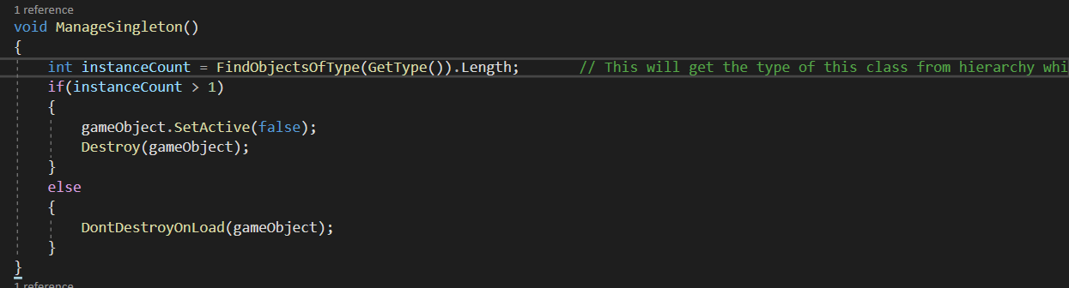

Method 2:

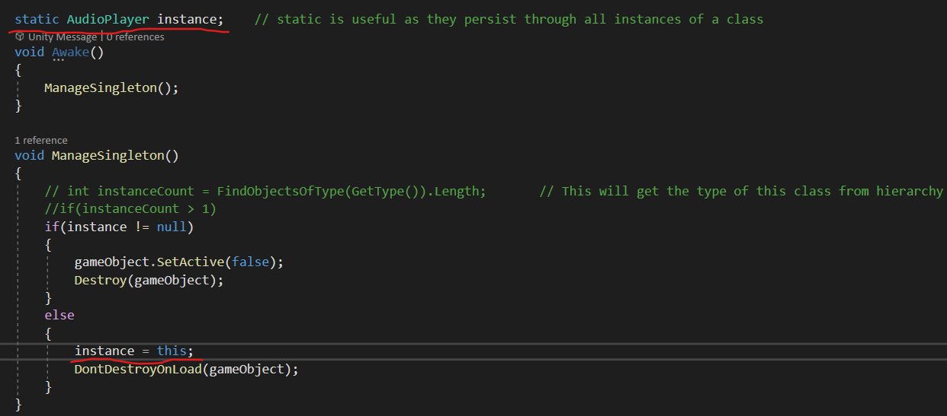

**Bottom Line: To keep the object persistent throughout the different scenes.**